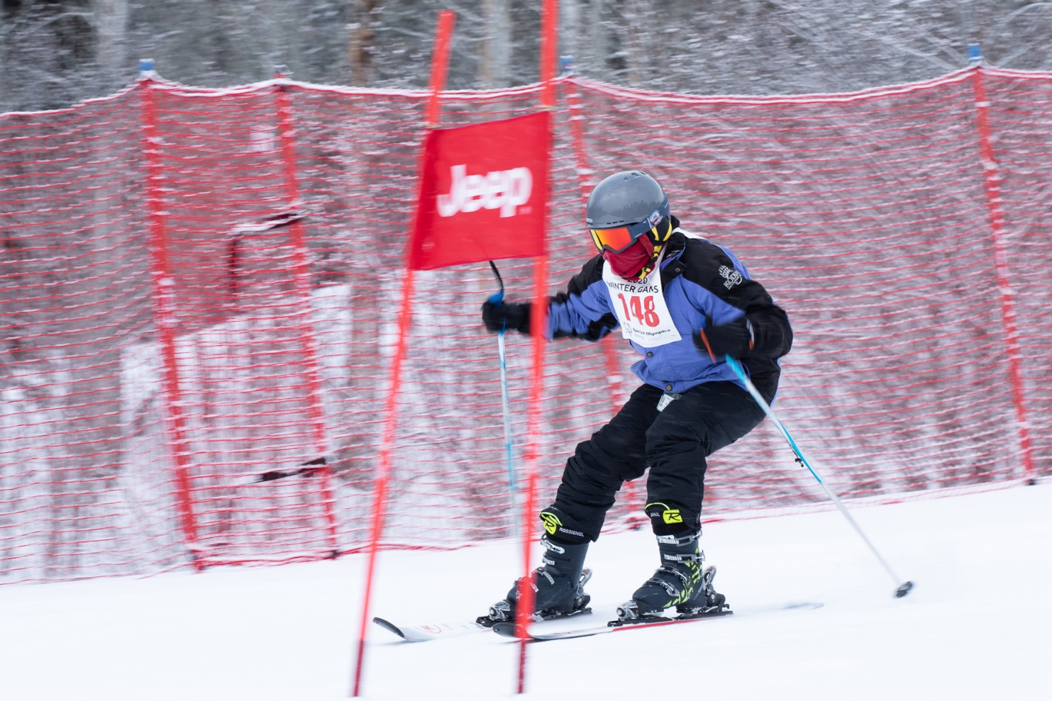

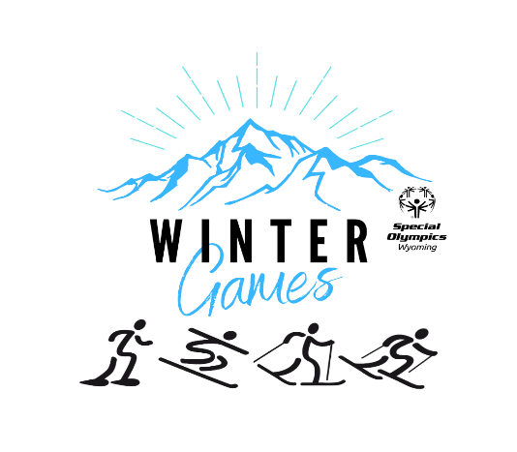
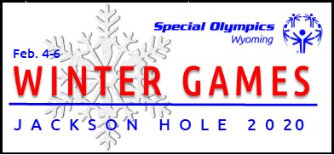
2021 Winter Games
Information Guide

COVID-19 Information

The pandemic continues to be a challenge with the massive and diverse amount of information, circumstances in our communities, and how we feel about it. As an organization, we continue to monitor the recommendations from the Special Olympics International as well as the Wyoming Department of Health directives.

2021 Winter Season Protocols
- Gathering guidelines (25 people or less including coaches) should be followed during training sessions.
- Temperature checks should be conducted at the start of every training session or competition.
- Attendance records are to be kept from each training session.
- Masks are recommended to be worn at all times when athletes are not competing.
- Please make sure to adhere to all facility rules and regulations regarding gatherings, mask usage, etc.
- All athletes, coaches and partners should have their own equipment (no sharing helmets and goggles).
- If equipment is being rented, please be sure to use sanitization wipes prior to using it.
- Anyone exposed to COVID-19 virus within 14 days of a training session or competition shall not attend any team functions and should notify local program coordinators and Special Olympics Wyoming.
Table of Contents
Table of Contents
I. Minimum Training Requirements 4
II. Area Games 4
III. State Winter Games 5
A. Events Offered 5
B. Tentative Block Schedule 6
C. Cost: 7
D. Divisioning: 8
E. Awards: 8
F. Meals: 8
G. Housing Information 8
H. Facilities 8
I. Special Events 9
J. State Winter Games- Games Management Team (GMT) 10
K. Families Information & Activities 10
IV. Winter Games General Rules 10
A. Assisted Rules: 10
B. Attire and Equipment 11
V. Registration Instructions for 2021 Winter Area and State Games 11

Minimum Training Requirements
The minimum training requirements are sport specific and must be achieved prior to state Winter Games. It is important that athletes are trained by trained coaches, preferably certified coaches for the appropriate amount of training weeks/hours per the requirements below. This ensures athletes gain enough sports skills and experience to successfully compete in competitions. Hours at Area Games competition are credited towards these requirements.
Alpine/Snowboard 8-10 weeks or 12 hours
Cross Country 8-10 weeks or 12 hours
Snowshoe 8-10 weeks or 12 hours

Area Games
Athletes are required to compete at Area Games prior to State competitions. The only exception is if a sport is not available for participation at area competition.
Please contact the Area Games Coordinator, listed below, about competition details:
Area | Date(s) |  | Location | Contact | Phone | Email
I | 1/22 |  | Antelope Butte Mountain Rec Area | Karen Beddoes | 307.330.4153 | AreaI@specialolympicswy.org
II | 1/15 |  | White Pine | Dan Lang | 307.235.3062 | AreaII@specialolympicswy.org
III | TBD | Ty City Trail Head |  | Marsha Dial | 307.220.0253 | AreaIII@specialolympicswy.org
IV | 1/21 |  | Terry Peak | Carrie Pilcher | 307.751.0539 | AreaIV@specialolympicswy.org
V | 1/17 |  | Hogadon/Casper Mountain | Dan Lang | 307.235.3062 | fieldservices@specialolympicswy.org

Area Games registrations can be found on the Special Olympics Wyoming website on the Area Games page or on the Winter Games page.
NOTE: All material in this document is relevant to area competitions except for information on schedules, housing, meals, volunteers, and special events.

State Winter Games
Alpine/Snowboard Levels:
I=beginner
IA=beginner assisted
II=intermediate
III-advanced
S-sitski

Athletes must compete at the same level for all events. For entry level alpine athletes the progression is:
- 10 Meter Race
- Glide
- Super Glide
- Super G Level 1

Events Offered
Each athlete is allowed to compete in ONE SPORT ONLY.

ALPINE:
Beginner/ Lower Ability Events | Official Events
Glide Event  10 meter race  Super Glide | Slalom  Super G Slalom  Giant Slalom
*Sit Skiers please note on registration
*Level 1 athletes may be entered in an assisted event which allows for a coach on the course

SNOWBOARD:
Beginner/ Lower Ability Events | Official Events
Super Glide | Slalom  Super G Slalom  Giant Slalom
*Athletes must enter consecutive distance.
For example:
10 m25 m50 m
Or
100m500m1km

*Athletes entered in relays must compete in a time trial for the individual event which constitutes one “leg” of the relay.
*Athletes may not compete in the same event as an individual and then as a member of a Unified Sports team.

CROSS COUNTRY:
Beginner/ Lower Ability Events | Higher Ability Events | Relay Events
10 m Ski Race  10 m Assisted Ski Race  25 m Ski Race  25 m Assisted Ski Race  50 m Ski Race  100 m Ski Race | 500 m Ski Race  1 km Ski Race  3 km Ski Race  5 km Ski Race | 4 x 1 km Relay  4 x 1 km Unified Sports Relay

SNOWSHOE:
Beginner/Lower Ability Events | Higher Ability Events | Relay Events
10 m Ski Race  10 m Ski Race  25 m Race  25 m Assisted Race  50 m Race  50 m Assisted Race  100 m Race | 200 m Race  400 m Race  800 m Race  1600 m Race | 4 x 100 m Relay  4 x 100 m Unified Sports Relay  4 x 400 m Relay  4 x 400 m Unified Sports Relay

Tentative Block Schedule
All athletes must compete in a time trial on Wednesday morning (in cross country and snowshoe they may compete in two). The Games Management software will automatically enter athletes in appropriate time trial events. Athletes should choose one event per block; exception is CC & SS may add one relay.
Note: Athletes entered in relays must compete in a time trial for the individual event that constitutes one “leg” of the relay.
 | February 3  Wednesday AM | February 3  Wednesday PM | February 4  Thursday AM | February 4  Thursday PM
Alpine (Jackson Hole Mountain resort) | Time Trials  (Modified Giant Slalom for all Alpine Athletes) | Glide Event  Slalom I,II,III | Super Glide  10 Meter Walk  Giant Slalom I, II, III  Super G Slalom III | Super G Slalom I, II
Snowboard  (JHMR) | Time Trials  (Modified Giant Slalom for all Snowboard Athletes) | Glide Event  Slalom I,II,III | Super Glide  Giant Slalom I, II, III  Super G Slalom III | Super G Slalom I, II
Cross Country (Jackson Middle School Fields) | Time Trials  *Short Distances  (10m, 25m, 50m) will complete a 25m time trial  *Medium (100m & 500m) will complete a 100 meter time trial  *Long (1k, 3k, 5k) will complete a 1k time trial | 10 meter Ski Race  10 meter Assisted Race  100 meter CC Ski Race  3 kilometer CC Ski Race | 25 meter Ski Race  25 meter Assisted Race  500 meter CC Ski Race  5 kilometer CC Ski Race | 50 meter CC Ski Race  1 kilometer CC Ski Race  4x1 kilometer CC Relay  4x1 kilometer Unified Sports Relay
Snowshoe  (Jackson Middle School Fields) | Time Trials  *Short Distances  (25m, 50m, 100m) will complete a 50m time trial  *Long (200m, 400m, 800m, 1600m) will complete a 200 meter time trial | 800 meter Race  100 meter Race  4x400 meter Relay  4x400 meter Unified Sports® Relay | 400 meter Race  50 meter Race  50 meter Assisted Race  4x100 meter Relay  4x100 meter Unified Sports® Relay | 200 meter Race  25 meter Race  25 meter Assisted Race  1600 meter Race

Cost:
There is a $42.50 assessment fee for registered athletes, Unified Sports® partners, coaches and chaperones. This fee covers costs of meals (two breakfasts, two lunches and two dinners) and associated competition costs (facility fees, rental equipment, supplies, and awards).

Divisioning:
Age Divisions: 8-15, 16-21, 22+
Divisions may be combined or subdivided according to the number of participants. Divisions will have a maximum of 8 participants.

Awards:
Individual medals will be awarded to the first 3 places in each division. Ribbons will be awarded to the remainder. Awards will be presented immediately following the conclusion of each heat.

Meals:
The following meals will be offered at the 2021 Winter Games:
 | Tuesday, Feb 2 | Wednesday, Feb 3 | Thursday, Feb 4
Breakfast |  | Elk’s Lodge | Elk’s Lodge
Lunch |  | Competition Sites | Competition Sites
Dinner | Jackson Hole HS | Snow King Resort
*Meal locations may be subject to change.
Notes regarding meals:
- If you or your athletes have specific dietary needs or do not like meals choices, please make arrangements to bring your own lunch, dinner or breakfast.
- Special Olympics Wyoming will not reimburse you if you choose not to eat one of our prearranged meals and go off site for food.
- It is important that local coordinators provide an accurate number of meals on the Delegation Registration Form for athletes, volunteers, and families to keep costs down.
- Please list the total number of extra meals expected for those other than participants on the registration cover page.

Housing Information
Teams are responsible for making their own hotel reservations. Snow King Resort is the host hotel again for the 2021 Winter Games; rooms are available for $99 per night and may be booked directly online at https://bit.ly/31TPSiZ

Facilities

Alpine Events
Jackson Hole Mountain Resort
3395 Cody Ln.
Teton Village, WY 83025
307.733.2292
Banquet & Host Hotel
Snow King Resort
400 E. Snow King Ave.
Jackson, WY 83001
307.733.5200

Breakfast
Elk’s Lodge
270 W. Broadway
Jackson, WY 83001
307.733.1713
Opening Ceremonies
Jackson Hole High School
1910 High School Rd.
Jackson, WY 83001
307.732.3700

Snowshoe & Cross County Events
Jackson Middle School Fields
100 Middle School Rd,
Jackson, WY 83001

Special Events
Torch Run
Tuesday, February 2, 2021 2:00pm-2:30pm Town Square

Torch Run Ceremonies
Tuesday, February 2, 2021 2:30pm Town Square

Opening Ceremonies
Tuesday, February 2, 2021 7:00pm-8:00pm Jackson Hole High School
Featuring:
Entertainment, Law Enforcement Torch Lighting

Victory Banquet & Dance
Wednesday, February 3, 2021 6:00pm-9:30pm Snow King Resort

Featuring:
Buffet style dinner & dance party
Theme: luau

State Winter Games- Games Management Team (GMT)
Special Olympics Wyoming would like to thank the Winter Games GMT for their hard work leading up to and at Winter Games. The GMT is made up of volunteers around Wyoming that work hard to ensure the 2021 Winter Games is the best possible experience for athletes, families and volunteers!
Karen Beddoes | Snowshoe Director | Carolyn Burke | Volunteer Coordinator
Christy Fox | Alpine Director | Smokey Rhea | Opening Ceremonies
Al Zuckerman | X Country Director | Jess McMillan | JHMR Liaison

Additional members may be added as they join our team!

Family Information & Activities
Special Olympics Wyoming knows the importance of family support to our athletes. As a thank you to family members we include their participation in most activities at competition.

Winter Games General Rules
The official Special Olympics Sports Rules for Alpine Skiing, Snowboarding, Snowshoeing and Cross Country Skiing shall govern all Special Olympics competitions. All Special Olympics rules have been created based on National Governing Body (NGB) rules and NBG rules shall be employed except when they are in conflict with Special Olympic modifications. All Special Olympics official rules can be found at http://www.sowy.org/index.php/resources/sports-coaches-resources.
- Athletes can compete in only one sport.
- Athletes must have completed training requirements and competed at Area Games before competing at Winter Games.
- Athletes may not compete in the same event in Unified Sports AND traditional Special Olympics competition.
- Please make every effort to match athletes with partners of similar age and ability.
- In order to properly division athletes for competition and provide the best competition possible for all participants, it is imperative that accurate and recent scores/times are provided on registration form for every participant in every event.

Assisted Rules:
- Athlete starts behind the start line with a walking aid.
- Athlete walks using a walking aid.
- Athlete stays in his/her designated lane.
- Athlete may not receive physical assistance from coaches, officials that provides forward momentum etc.

The following rules are for athletes with visual or hearing impairments:
- A rope or sighted guide runner may be provided to assist athletes who are visually impaired.
- A sighted guide runner may not be ahead of the athlete in any manner. At no time may the guide runner pull the athlete or propel the athlete forward by pushing.
- A tap start will be used for an athlete who is both deaf and blind.
- Guide runners must wear a bright orange running vest so that they are clearly distinguished from competitors.

Attire and Equipment
- Athletes must wear athletic attire appropriate for their sport and weather conditions.
  - Please refer to the Coordinators Manual Page on our website.
  - Special Olympics Wyoming requires that all teams ordering any new equipment with a Special Olympics North America approved logo send proof to Erin Gamroth. Erin will provide quick response and will not delay the printing process at any point. Questions regarding logo use or any other branding questions should be directed to Erin at specialevents@specialolympicswy.org or (307)235-3062.
  - Jeans not appropriate for any competitors.
- Teams must provide their own adaptive equipment for all sports.
- A helmet is required for all athletes training and/or competing in Alpine and Snowboard events. Special Olympics North America has updated their helmet regulations for Alpine Skiing. The new regulations are;

Under the new regulations, helmets must bear a CE mark and conform to recognized and appropriate standards such as CEH.Din 1077, ASTM F2040, SNELL S98 or RS 98. In addition, in order to attest that a helmet fulfills all FIS requirements, it must have a conformity label affixed by the manufacturer in a non-removable way, at the back of the helmet, in a position where it is not covered by the goggle strap. The conformity label must contain the text “Conform to FIS Specifications RH 2013”.

Special Olympics Wyoming will allow the use of current helmets but when purchasing any new helmets, you must follow these new regulations.

Registration Instructions for 2021 Winter Area and State Games
The following forms must be included for your registration to be complete:
Form 1: Delegation Registration Cover Sheet
Form 2: Sports Registrations OR GMS Exchange file
Note: You must complete registration forms for Area Games AND registration forms for State Games by designated deadlines.
All forms can be found on the Winter Games page of the website.
Please send registration materials to the following:
Competition | Registration Deadline | Forms Returned To:
Area I | Friday, January 8 | Karen Beddoes
Area II | Friday, January 1 | Dan Lang
Area III | TBD | Marsha Dial
Area IV | Thursday, January 7 | Carrie Pilcher
Area V | Sunday, January 3 | Dan Lang
State Games | Monday, January 18 | Bobby Casey

Contact Bobby Casey for any technical support or additional assistance: sports@specialolympicswy.org or (307) 235-3062.

