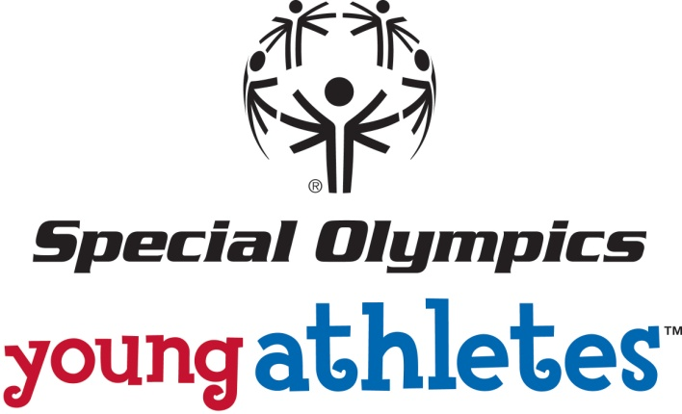

**MCj04061200000[1]**

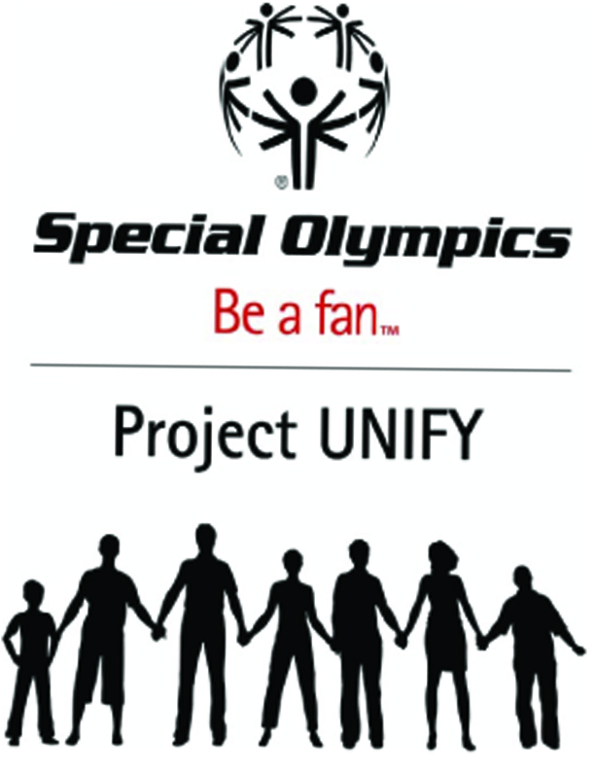

Athlete Leadership Programs

 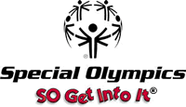

**Program Activities**

### **Project UNIFY**

The Special Olympics National Youth Activation Program – Project UNIFY – **seeks to actively engage youth with and without disabilities in the Special Olympics movement**. The purpose of Project UNIFY is to build communities of acceptance and inclusion through the engagement of young people both with and without intellectual disabilities not only in their schools but also at local, state, national levels.

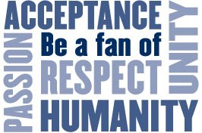

The basic approach of Project UNIFY will be to build upon existing partnerships and to initiate new partnerships between Special Olympics and the educational community. In Project UNIFY, Special Olympics leaders at the state and community level will be supported to develop a collaborative relationship with education leaders and youth to create “Project UNIFY Schools”. Established as well as new initiatives designed to fill gaps, will be integrated in combinations that lead to the **empowerment of students with and without intellectual disabilities working together as agents of change**.

As a result of Project UNIFY we hope to generate greater active engagement by all youth (pre-school and up) with and without intellectual disabilities in Special Olympics; to educate and sensitize all American youth, **change the attitudes of youth toward people with intellectual disabilities and empower them to be societal agents of change for acceptance**; activating them collectively as a catalyst for change among government, civic, corporate and independent sectors.

U.S. Department of Education funding will support U.S. based initiatives that actively engage youth nationally in Special Olympics activities, to educate and sensitize all American youth as to what it means to have an intellectual disability, and **change the attitudes of youth toward people with intellectual disabilities**. These programs will have broad national exposure, and should have a major impact on the activities in each U.S. Program.

Staff Liaison: Allison Harker- [program@specialolympicswy.org](mailto:program@specialolympicswy.org)

1. **Young Athlete Program**

[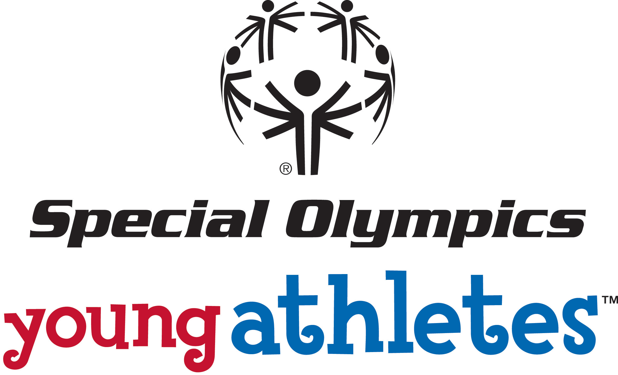](http://www.sonj.org/HomePage/YoungAthletes.php)

The **Young Athlete Program** is an opportunity to open the door for participation of those athletes throughout the state at an age of transition-from early intervention program completion to pre-school and early elementary school years.

* Activities: The activities presented in the program are designed to develop the fundamental prerequisite skills to prepare athletes for future participation in sports.
* Equipment: The program includes user friendly instructions and a complete kit of sports activity equipment. The design of this program provides flexibility for the parent/sibling, paraprofessional, teacher, peer, and volunteer to conduct these activities. The **Young Athlete Program** can be used in a one on one setting at home or in a preschool/school environment.

A kit will be provided to each family working with their young athlete.

* Benefits: The **Young Athlete Program** offers families the opportunity to share in the success of their future athletes. Inclusive activities help promote and encourage social development and most importantly, families will learn of the potential of their child through their preparation for participation in sport.
* Skill Development: Foundational skills-Walking and Running-Balancing and Jumping-trapping and catching-throwing-striking-kicking-advanced skills. The **Young Athlete Program** includes several resources to guide family members and professionals as they conduct the program with family members and peers, and all resources are free of charge

1. Young Athletes Activity Guide-descriptions of the official Young Athletes activities
2. Training DVD- instructional video of children performing the activities
3. Young Athletes equipment Kit-equipment needed to perform the activities
4. [www.specialolympics.org/youngathletes-](http://www.specialolympics.org/youngathletes-) further resources, materials and information

After 8 weeks of training, Special Olympics Wyoming will offer a participation event where the Future Stars can shine with their peers and families to display their new skills. Whatever your skill level and whatever your motivation for participating and competing, there is always an opportunity to excel and have fun.

For more information, to register, or to start a Young Athlete program in your community please contact

Dede McDonald, Young Athlete Program Manager, [dedmcdon@wyoming.com](mailto:dedmcdon@wyoming.com)

Staff Liaison: Arian Currah- [fieldservices@specialolympicswy.org](mailto:fieldservices@specialolympicswy.org)

1. **Healthy Athletes**

The mission of Special Olympics Healthy Athletes®, developed in 1996, is to improve athletes' ability to train and compete in Special Olympics. Healthy Athletes is designed to help Special Olympics athletes improve their health and fitness, leading to enhanced sports experience and improved well-being.

**Special Smiles Clinician: Pauline Phillips**

Special Olympics Special Smiles is one of the core components of the Special Olympics Healthy Athletes initiative, created to focus attention on the overall health issues facing Special Olympics athletes. The mission of Special Smiles is to increase access to dental care for Special Olympics athletes, as well as all people with intellectual disabilities.

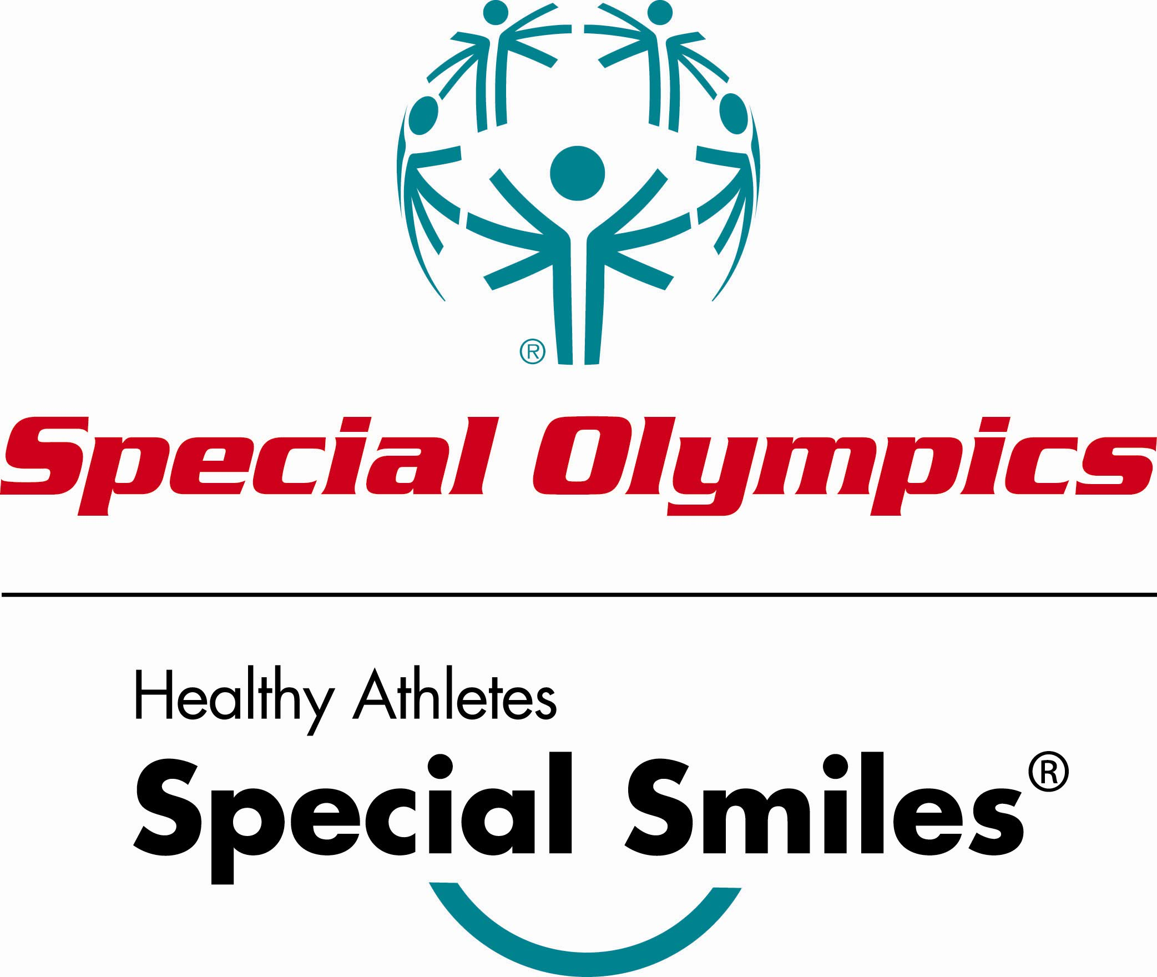

Dental screenings are used as a means to increase awareness of the state of the athletes' oral health for the athletes themselves, as well as their parents and/or caregivers. The athletes are provided with hygiene education to help ensure they are doing an adequate job of brushing and flossing, as well as nutritional education to understand how their diet affects their total health. The athletes also are provided with a list of dentists/clinics in their area that will treat patients with special needs, should they have difficulty finding a dentist. At most locations, free mouth guards are provided for athletes competing in contact or high-risk sports.

**FUNfitness Clinician: Dede McDonald**

FUNfitness is the comprehensive physical therapy component of the Special Olympics Healthy Athletes initiative. FUNfitness is designed to assess and improve flexibility, functional strength and balance; to educate participants, families and coaches about the importance of flexibility, strength and balance; and to provide a hands-on opportunity for participants to learn about physical therapy.



At a FUNfitness screening event the physical therapist assesses flexibility and balance. Physical therapist assistants, and physical therapist or physical therapist assistant students work during the screening under the direction and supervision of the physical therapist.

FUNfitness also provides "take-away" educational materials for Special Olympics athletes and information for families and coaches about the importance of and methods to improve flexibility, functional strength and balance in sports performance and activities of daily living.

**Opening Eyes Clinician: Sue Lowe**

Objectives of Opening Eyes includes providing screenings to Special Olympics athletes educating athletes, parents and coaches about the importance of regular eye care; educating and changing attitudes of eye care professionals about the vision care needs of persons with intellectual disabilities worldwide; and increasing knowledge of visual and eye health needs of persons intellectual disabilities through research.

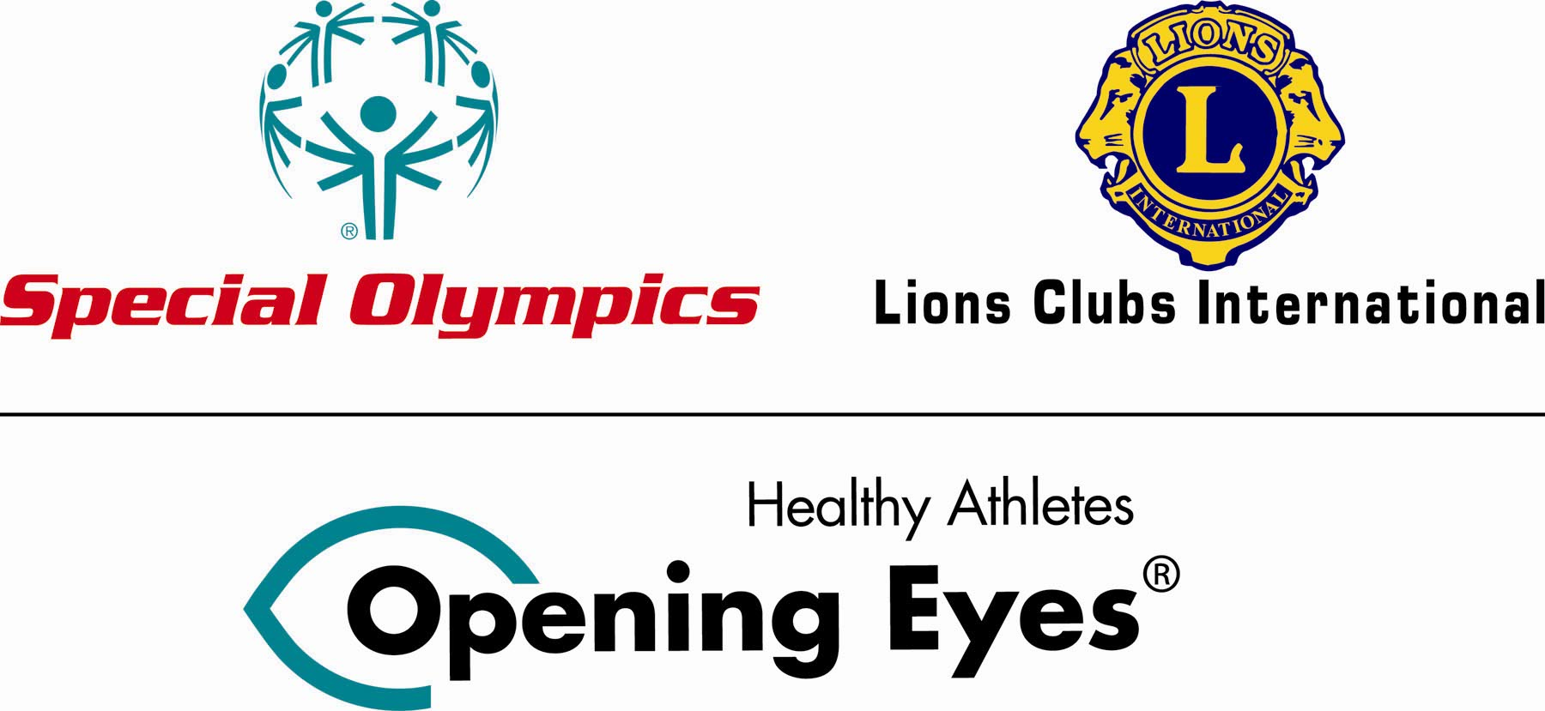

### **D. Athlete Leadership Programs (ALP’s)**

Athlete Leadership Programs (ALP’s) are an opportunity to involve Special Olympics athletes in a non-traditional component of Special Olympics.

***1. What is the goal of Athlete Leadership Programs (ALPs)?***

1. Allowing athletes **to choose for themselves** how and in what role they participate in Special Olympics.
2. Supporting athletes in meaningful **positions of influence and leadership** throughout the organization to help determine policy and set direction.
3. Providing training for existing leadership as they welcome athletes in their new roles.

***2. Athlete Leadership Programs***

|  |  |  |
| --- | --- | --- |
| Traditional Sports Programs | Unified Sports™ | Athletes as Volunteers |
| Athletes as  Officials | Athletes as  Coaches | Athletes on Boards and Committees |
| Sergeant Shriver Global Messenger | Athlete Congress/  Leadership Workshops | Athlete Input Councils |

Special Olympics Wyoming Global Messengers

* Lisa Allen Laramie
* Sammie Andrew Casper
* Alex Bluemel Bridger Valley
* Jeannie Ellinger Sheridan RENEW
* Cory Francis Gillette Masters
* Kristin Gertge Cheyenne
* James Grabrick Gillette
* David Hansen Thermopolis
* Julie Huber Casper
* Mike McKnight Casper
* Tim McLaurin Jackson
* Mycah Miller Jackson
* Jeff Mock Sheridan RENEW
* Tess Robinson Casper
* Lucas Tronquet Sweetwater Cty
* Brian Tronquet Sweetwater Cty
* Sarah Widdoes Douglas
* Jordan Yager Riverton

1. **Special Olympics Get Into It (SOGGII)**

*A* ***free*** *resource curriculum kit to involve youth in Special Olympics*

C:\Program Files\Microsoft Office\MEDIA\CAGCAT10\j0299125.wmf

***SO Get Into It*** is a fully scripted four-lesson curriculum unit for three grade levels:

Elementary (K-5)

Middle (6-8)

High school (9-12)

***SO Get Into It*** provides:

1. Tools for involving children and youth with and without intellectual disabilities in Special Olympics.

2. Curriculum designed to help schools and teachers meet a variety of requirements and needs.

**These include:**

Academic achievement standards

Understanding and acceptance of individual differences

Youth development and character education

**A Focus on academics at the elementary & middle school level**

Lessons fit into the activities of social studies, language arts, history, health and physical education program

**A Focus on Physical Education at the High School Level**

Lessons fit into the activities of the high school physical education program

* + Lessons support all NASPE physical education standards, in particular:
    - #5 - Responsible personal and social behavior
    - #6 - Understanding and respect for difference among people
    - #7 - Physical activity is an opportunity for social interaction

Each kit includes all necessary materials, including videos and a CD! You can also download the printed materials from [www.specialolymipcs.org/getintoit](http://www.specialolymipcs.org/getintoit).