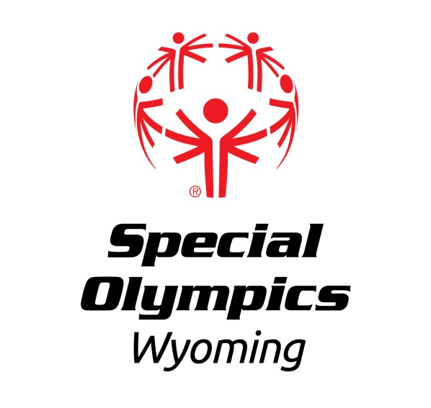

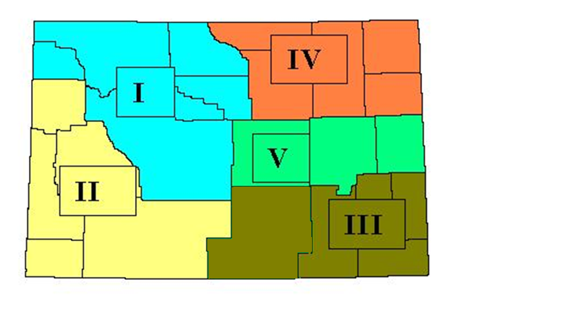

Area & Local Programs

**A. Counties & Communities by Area**

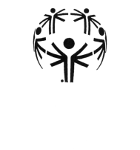

Area 1

Northwestern

Wyoming

Area Director

Lauren Stocchetti

Counties:

Big Horn

Fremont

Hot Springs

Park

Washakie

Communities

Arapahoe

Basin

Byron

**Cody**

Cowley

Dubois

**Ethete**

**Fort Washakie**

Greybull

**Lander**

Lovell

Lucerne

**Powell**

**Riverton**

Shoshoni

**Thermopolis**

Wind River Res.

**Worland**



# Area 2

Southwestern Wyoming

Area Director

open

Counties:

Lincoln

Sublette

Sweetwater

Teton

Uinta

Communities

**Afton**

Alpine

Cokeville

Diamondville

**Evanston**

**Green River**

Hoback

**Jackson**

Kemmerer

**Lyman**

Marbleton

Moose

**Mountain View**

Pinedale

Reliance

**Rock Springs**

**Star Valley**

**Wilson**



Area 3

Southeastern Wyoming

## Area Director

Sheila Luna

Counties:

Albany

Carbon

Goshen

Laramie

Platte

Communities

**Cheyenne**

Guernsey

**Laramie**

Lusk

Lingle

Pine Bluffs

**Torrington**

**Wheatland**



# Area 4

Northeastern

Wyoming

Area Director

Anita Badgett

Counties:

Campbell

Crook

Johnson

Sheridan

Weston

Communities

**Buffalo**

Dayton

**Gillette**

**Moorcroft**

**Newcastle**

Ranchester

**Sheridan**

Story

**Sundance**

Upton

Wright



# Area 5

Central

Wyoming

## Area Director

#### Robert Peterson

Counties:

Converse

Natrona

Niobrara

Communities

**Bar Nunn**

**Casper**

**Douglas**

**Evansville**

**Glenrock**

**Mills**

Rawlins

Saratoga

Hanna

**B. Area & Local Programs**

|  |
| --- |
| Local Program A local program is a school, organization or training group made up of registered Special Olympics Wyoming athletes. |

|  |
| --- |
| Area Program Special Olympics Wyoming believes that support services should be provided as close to local Special Olympics programs as possible. To accomplish that, Special Olympics Wyoming Areas have been developed. A Special Olympics Area is one of five geographic areas of the state, established to increase the level of service and resources available to local programs within that Area.  The goal of the area is to assure the following is accomplished:   * Provide the opportunity for preliminary competition prior to every state event. * Provide training opportunities for volunteers and athlete leaders. * Establish a continuing funding source to sustain the activities for the area and local programs. * Provide financial planning and budgeting for local programs. |



LOCAL PROGRAM LOCAL PROGRAM CONTACT

# AREA I Lauren Stocchetti

Cody Lauren Stocchetti

Lander Masters Karen Beddoes

Lander Valley Schools Candice Hudson

Powell Chris Wolff

Riverton Carol Strohecker

Thermopolis Schools Thomas Olsen

Washakie County Yvonne Bryant

# AREA II

Bridger Valley Spencer Crossland

C Bar V Ranches Don Carr

CES – Jackson Keverin Burns

Evanston Open

Jackson Therapeutic Riding Center Donna Johnsen

Star Valley Russell Gardner

Star Valley Masters Erin Gardner

Star Valley Masters LSR Joe Park

Sweetwater County Logan Meeks

Teton County Schools Tim Miles

# AREA III Sheila Luna

Cheyenne Wanda Brent

Goshen County Dick Gulisano

Laramie Trudy Snyder

Platte County Kathy Garton

# AREA IV Anita Badgett

Buffalo Teresa Hicks

Crook County Jim Benvenga

Gillette BOCES Bonnie Queen

Gillette Masters Phil Grabrick

Gillette Schools BJ Francis (winter)

Jodi’s Heart Kyle Smith

Newcastle RENEW Debra Hoover

Newcastle Schools Laura MacLean

Sheridan RENEW (Masters) Carrie Pilcher

Sheridan Easter Seals (Masters) Jesse Dahl

Sheridan Schools Tanna Cotton

Sol Domus Carlos De Le Rosa

# AREA V Robert Peterson

Casper Robert Peterson

Douglas Chyann Howard

Glenrock Andrea Eason

* Local and Area Contact information can be found at [www.SOWY.org](http://www.SOWY.org).

**C. Getting Started**

## Getting a New Athlete

**Involved With**

**Special Olympics Wyoming**

The Mission of Special Olympics Wyoming is to provide year round sports training and competition in a variety of well coached Olympic-type sports for individuals with intellectual disabilities by providing them with continuing opportunities to develop physical fitness, skills, express courage, experience joy, and participate in the sharing of gifts, skills, and friendship with their families, friends, other Special Olympics athletes and the community.

# **A FEW EASY STEPS**

Getting a new athlete or team involved with Special Olympics Wyoming is easy, and there is no “fee” or assessment that an athlete must pay for participation:

# MCj04039250000[1]

* First, potential Special Olympics athletes must be at least eight years old and be a person with intellectual disabilities or a closely related developmental delay. A detailed explanation of eligibility is available on page 10 of this manual.
* Second, the potential athlete must submit an Application for Participation in Special Olympics (or medical) to the Special Olympics Wyoming office. This is a health information form that must be signed by a medical professional.
* Third, the potential athlete must submit a Special Olympics Release Form (or consent). Athletes under the age of 18 or who have guardians appointed must have their parent or guardian sign the Form. Athletes who are 18 years of age or older may sign the Release themselves.

Please complete both the Application for Participation and the Special Olympics Release Form. Have them signed appropriately and return them to the Special Olympics Wyoming office.

# **SCHOOLS and AGENCIES**

If the athlete is a student at a school or is a client of a habilitation agency that provides direct services, there may already be a Special Olympics Team associated with that facility. The athlete may be able to join that existing program.

If there are no Special Olympics training programs convenient to the athlete, Special Olympics Wyoming will forward that information to the Special Olympics Area program that covers that Area of the state.

Schools or agencies, which are interested in starting a Special Olympics program should contact the Special Olympics Wyoming office for further information.

**QUESTIONS or to VOLUNTEER:**

If you have any questions about participating in our year-round program please call us at 1-800-735-8345 or in Casper 235-3062. Experience not required!

Special Olympics Wyoming

**232 East 2nd St.**

**Suite 201**

**Casper, WY 82601**

**www.specialolympicswy.org**